PHYS 104 Lab 9 OPTICS PART 1

Introduction

In this lab you will study the *reflection* and *refraction* of light. You will use an **Optical Bench**, a **Ray Table**, and **mirrors**. You will tabulate your results using **Excel**.

Theory

Nearly all objects *reflect* some of the light incident upon them. It is this *reflected* light that allows us to see the objects. Many surfaces are very irregular and *reflect* light almost equally in all directions producing what is called *diffuse reflection*. Surfaces suffi­ciently smooth so that any irregularities are small compared to the *wavelength* of light *reflect* light in basically one direction. This is called *specular reflection* which occurs, for example, when you observe an image *reflected* by a mirror.

When light is *reflected specularly*, the *angle of incidence* θi equals the *angle of reflection* θr (see figure 1). Both of these *angles* are measured from the line perpendicular to the mirror’s surface at the point where the light ray strikes it which we call the *normal*.

θi = θ r ***Law of reflection*** (1)

Normal

Reflected

ray

Incident

ray

θr

θi

**Figure 1. Reflection of a ray.**

**mirror**

Procedure

Part 1. Reflection

1. Set up the lab equipment as shown in figure 2 below.
2. Adjust the light source so a single *ray* of light is aligned with the bold arrow labeled "*Normal*" on the **Ray Table Degree Scale**.
3. Carefully align the flat surface of the **mirror** with the bold line labeled "Component" on the **Ray Table.**

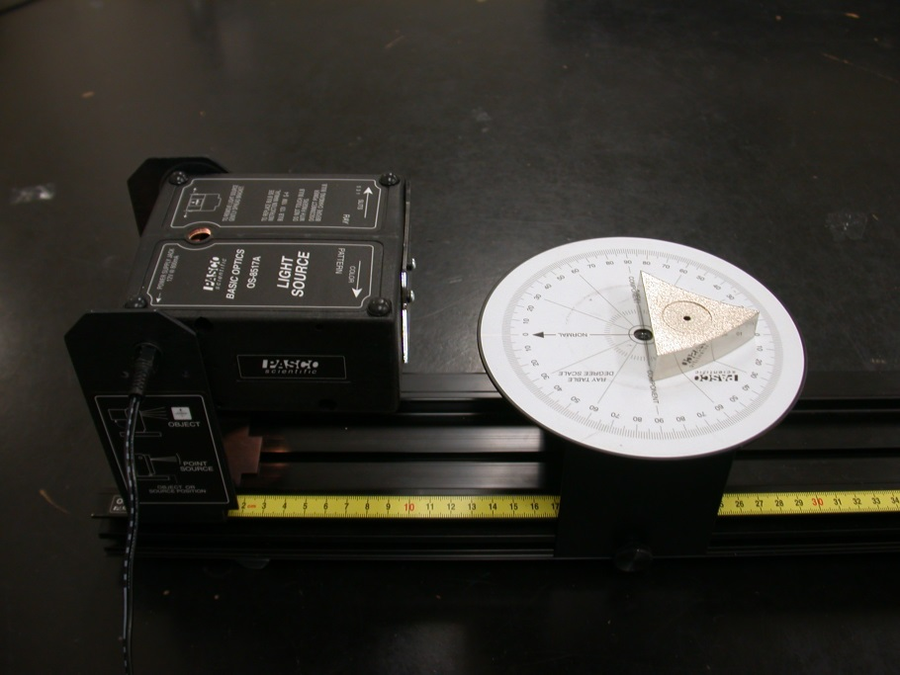

**Figure 2. Reflection setup.**

1. Rotate the **Ray Table** and observe the light *ray*. The *angles of incidence* and *reflection* are measured with respect to the *Normal*, as shown in figure 3.



Figure 3. Rotating table and angle measurements.

1. By rotating the **ray table**, set the *angle of incidence* to each of the settings shown in Table 1 below. For each *angle of incidence*, record the *angle of reflection* (Reflection A). Repeat your measure­ments with the incident ray coming from the opposite side of the normal (Reflection B) i.e if your original incident ray was left of the normal at 30°, repeat that measurement with incident ray being right of the normal at 30°. This allows us to compensate for an imperfect alignment of the mirror with the “Component” line. Calculate the average of the two trials for each *angle of incidence*.

### Table 1. Reflection

|  |  |  |  |  |
| --- | --- | --- | --- | --- |
| θi | θr A | θr B | Average θr | % Difference |
| **30°** |  |  |  |  |
| **40°** |  |  |  |  |
| **50°** |  |  |  |  |
| **60°** |  |  |  |  |

1. Are the results for the two trials the same within our measurement accuracy? If not, to what do you attribute the differences?
2. Did you verify the *law of reflection* given by equation (1)? Discuss.

Part 2. mirrors - Ray Tracing

1. Place the light source directly on the table and adjust the movable plastic in front to create a beam of five parallel rays.
2. Place a sheet of paper in front of the light source and put the flat mirror in front of it centering it on the middle ray.
3. Trace the surface of the mirror on the paper sheet and then trace the ray pattern as the light reflects from the flat side of the **Ray Optics Mirror** with the incident beam at 0° to the normal. For each ray use arrows to indicate the direction if light.
4. Repeat steps 2 and 3 but with the flat side of the mirror rotated so the beam is no longer incident at 0° to the normal.

5. Repeat steps 2 and 3 with the concave side of the **Ray Optics Mirror** and with the incident beam at 0° to the normal. Make sure that the central ray is incident at the center of the mirror.

6. Pull the sheet out and measure the distance from the center of the mirror to the focal point (the point where the rays converge). This is the *focal length* of your mirror. Record this value.

7. For spherical mirrors the focal length is equal the half of the radius of curvature of the mirror. Can you come up with an idea of how to confirm that? Describe briefly what you did to establish the radius of curvature for your mirror and record the measured radius. Do your results for the focal length and the radius of curvature match reasonably well?

8.Repeat steps 2, 3, 6 and 7 with the convex side of the **Ray Optics Mirror** and with the incident beam at 0° to the normal. Make sure that the central ray is incident at the center of the mirror.

9. Discuss your results.

10. Attach your sketches to your report.

**lab 9 Report** Name……………………………...

Name……………………………...

Name……………………………...

Data Presentation:

Part 1. Reflection

6.

7.

Part 2. mirrors - Ray Tracing

6.

7.

8.

9.

**REMINDERS:** Include units.

Make sure to attach all your data and graphs. No data = No credit

Please do not hand in the manual, just the report.